Lab 1:

**From Google Cloud Console**

**Determine if OS Config API is Enabled for the Project**

1. Navigate into a project. In the expanded navigation menu located at the top left of

the screen hover over APIs & Services. Then in the menu right of that select API Libraries

2. Search for "VM Manager (OS Config API) or scroll down in the left hand column and select the filter labeled "Compute" where it is the last listed. Open this API.

3. Verify the blue button at the top is enabled. Determine if VM Instances have correct metadata tags for OSConfig parsing

1. From the main Google Cloud console, open the hamburger menu in the top left. Mouse over Computer Engine to expand the menu next to it.

2. Under the "Settings" heading, select "Metadata".

3. In this view there will be a list of the project wide metadata tags for VMs. Determine if the tag "enable-osconfig" is set to "true".

**Determine if OS Config API is Enabled for the Project**

1. In each project you wish to enable run the following command

gcloud services list

2. If osconfig.googleapis.com is in the left hand column it is enabled for this project.

Determine if VM Manager is Enabled for the Project

1. Within the project run the following command:

gcloud compute instances os-inventory describe VM-NAME \

--zone=ZONE

Lab

Search for patch and select the first option

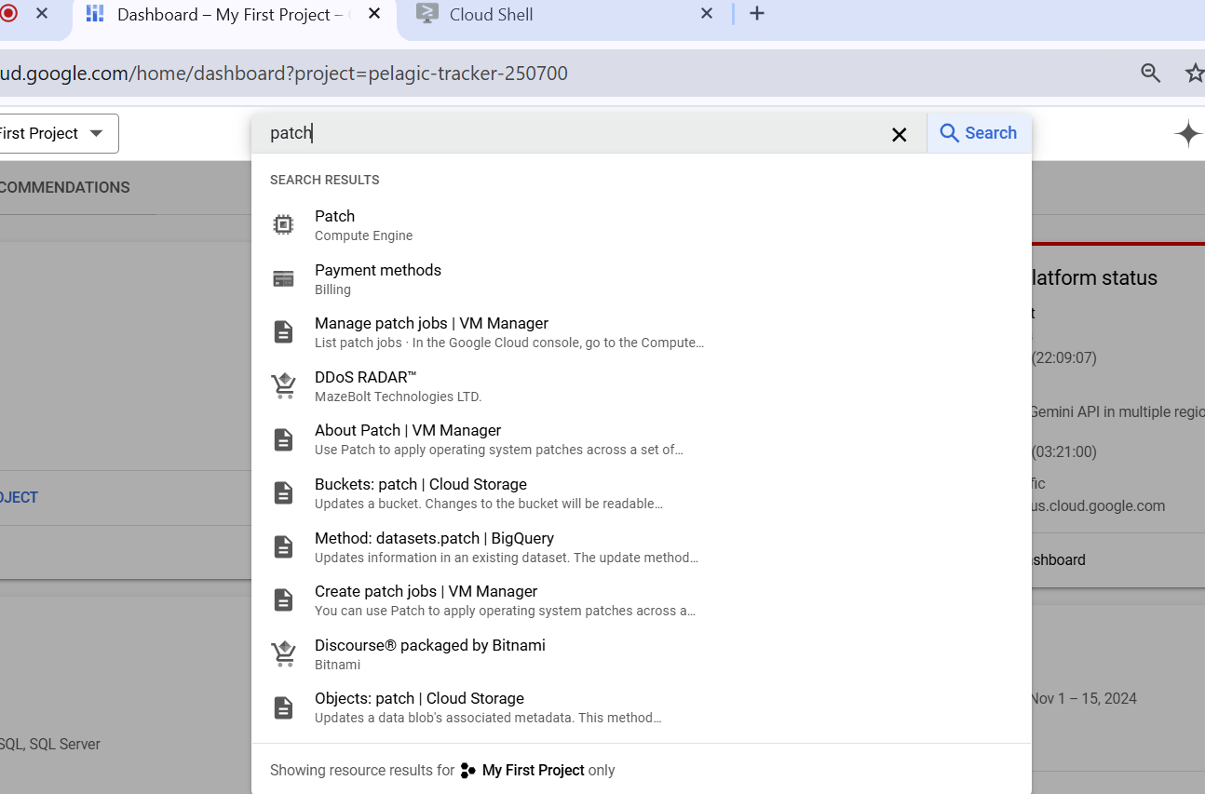

Click on Create patch job

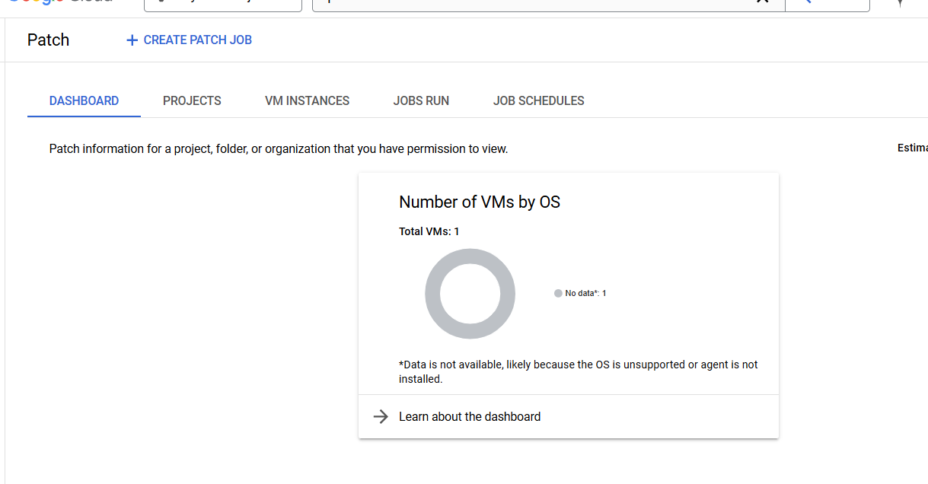

Select the manual option

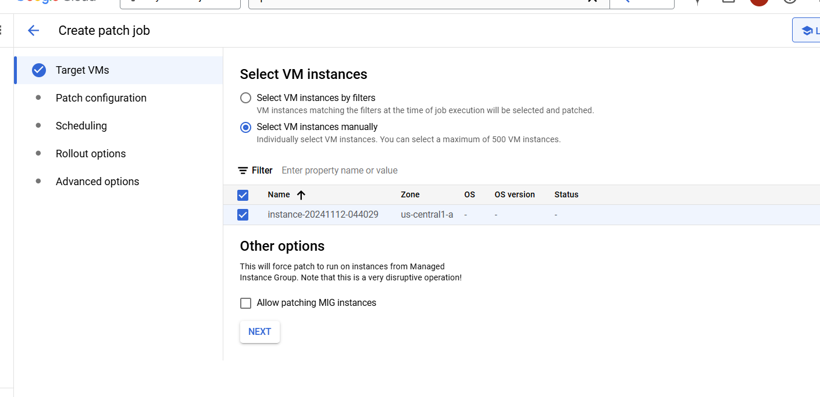

Select the patch parameter as per need

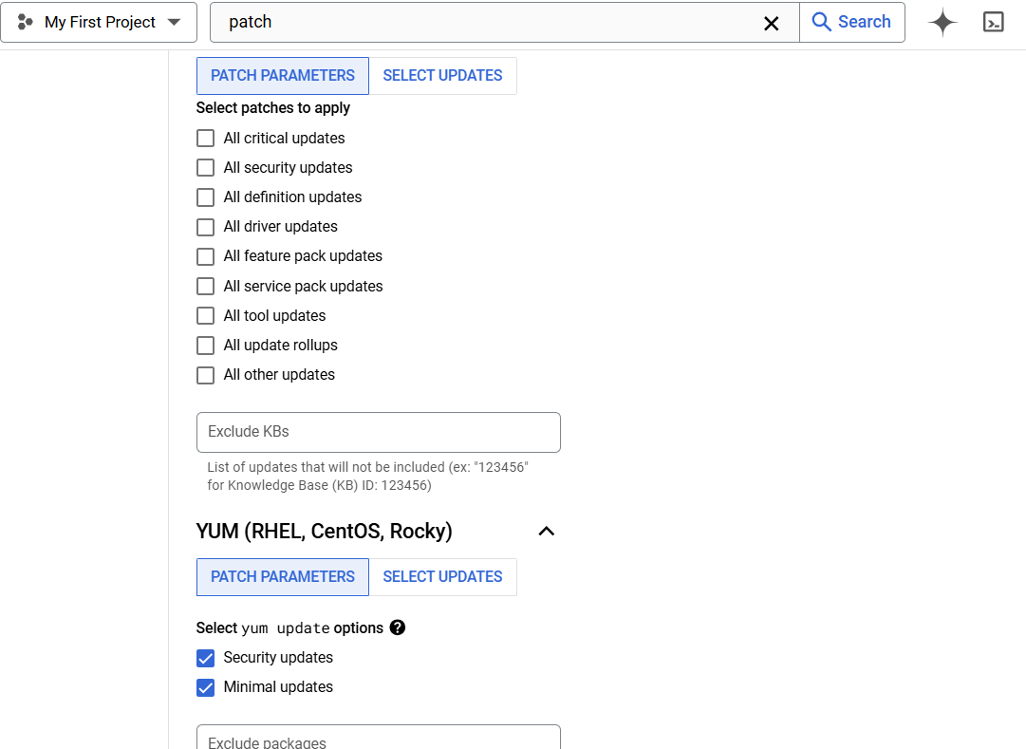

Select the option

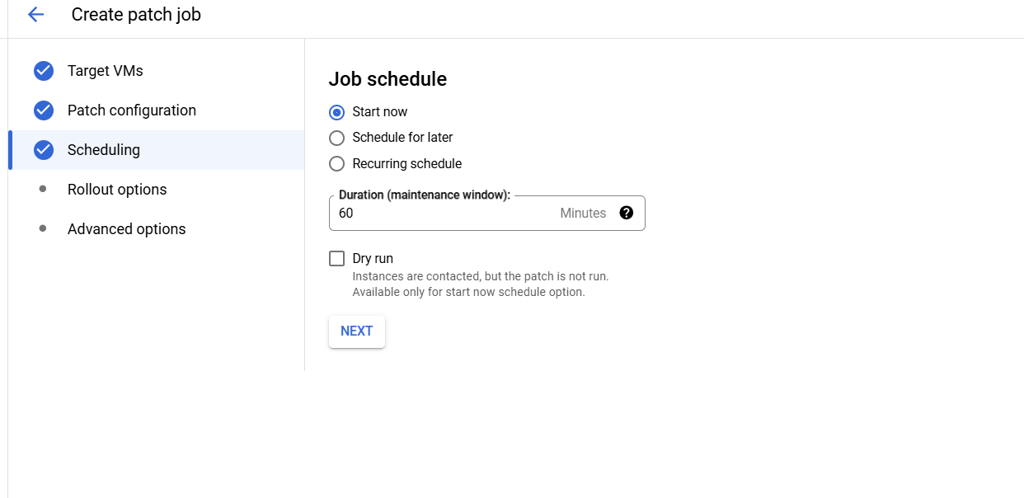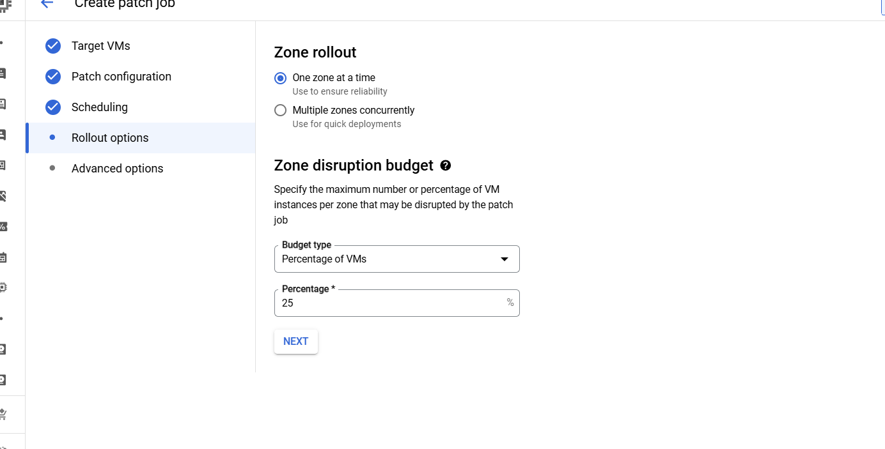

Any custom script you want to run

